2.1 Experiment No. : 02
2.2 Experiment Name : Application of Various Kinds of Html Attributes

2.3 Theory
This experiment demonstrates the application of various HTML attributes and elements that enhance the structure, presentation, and semantic meaning of web content. The code incorporates multiple types of attributes such as formatting, linking, multimedia, semantic tags, and CSS styling methods to create a well-organized and accessible webpage. Key concepts and elements used include:
- Text Formatting Elements and Attributes
  - <b> — Applies bold styling for visual emphasis without semantic meaning.
  - <mark> — Highlights text to attract attention, typically with a yellow background.
  - <strike> — Displays text with a strikethrough to indicate deletion or obsolete content (deprecated; <s> preferred).
  - <strong> — Adds semantic importance with bold styling, aiding assistive technologies.
  - <i> — Italicizes text for stylistic purposes without semantic emphasis.
  - <em> — Italicizes text while conveying semantic emphasis or stress.
  - <br> — Inserts a line break within text to control formatting.
- Linking and Reference Attributes
  - <a> tag with href — Creates hyperlinks to other web resources.
  - rel="nofollow" — Tells search engines not to follow the link for SEO purposes.
  - target="_blank" — Opens the linked page in a new browser tab or window.
- Quotation and Abbreviation Elements
  - <blockquote> with cite — Marks extended quotations, with the source URL specified by the cite attribute.
  - <abbr> with title — Defines abbreviations or acronyms, showing the full form on hover.
  - <cite> — Represents titles of creative works, usually rendered in italics.
- Contact Information Tag
  - <address> — Provides semantic markup for physical or organizational contact details, improving accessibility.
- Image Attributes
  - <img> tag with src and alt — Embeds images with the source file and descriptive alternative text for screen readers and fallback display.
- CSS Styling Methods
  - Inline CSS: Applied directly using the style attribute on elements for quick, element-specific styling (e.g., style="color: chocolate").
  - Internal CSS: Defined within a <style> block in the <head>, allowing centralized styling rules affecting multiple elements on the page.
  - External CSS: Linked via <link rel="stylesheet"> to separate stylesheet files for better maintainability and scalability.
2.4 Problem Statement
Create a webpage applying various HTML attributes to enhance structure, presentation, and accessibility.
2.5 Source Code
<!--index.html-->
<!DOCTYPE html>
<html lang="en">
<head>
<meta charset="UTF-8" />
<meta name="viewport" content="width=device-width, initial-scale=1.0" />
<title>BAUET Information</title>
<link rel="stylesheet" href="./style.css" />
</head>
<body>
<header>
<h1>Information about BAUET</h1>
<p>Bangladesh Army University of Engineering and Technology</p>
</header>

<main>
<section>
<p>Welcome to BAUET. It is located in Kadirabad, Natore.</p>
<a href="https://bauet.ac.bd" rel="nofollow" target="_blank"
>Visit BAUET Website</a
>
<img
alt="Honorable Vice Chancellor Sir"
src="./images/Brig-Gen-S-M-Lutfor-Rahman-279x300.jpg"
/>
</section>

<section>
<h2>Students</h2>
<p>There are <b>Allah Jane</b> students.</p>

<h2>Teachers</h2>
<p>There are total <b>Allah Jane</b> teachers.</p>

<h2>Departments</h2>
<p>There are total <b>13</b> departments.</p>
</section>

<section>
<h3>Second Lab Activity</h3>
<p>
This is our
<b
><mark><strike>Second lab</strike></mark></b
>
and today's morning is <strong>cloudy</strong>. This is a
high time for <i>sleeping</i>,<br />
but we have to <em>attend</em> our class.
</p>

<blockquote cite="https://bauet.ac.bd">
"Education is the most powerful weapon which you can use to
change the world." — Nelson Mandela
</blockquote>

<p>
This university
<abbr
title="Bangladesh Army University of Engineering and Technology"
>BAUET</abbr
>
was established in 2015.
</p>
</section>

<section>
<h3>Contact Information</h3>
<address>
University Name: BAUET <br />
Village: Dayarampur <br />
Post Office: Kadirabad <br />
Upazila: Bagatipara <br />
Zilla: Natore <br />
Division: Rajshahi
</address>
<p><cite>The University</cite> was founded by a BG.</p>
</section>

<section>
<h3>Application of Inline CSS</h3>
<p style="color: chocolate">
Good morning everyone, and Web Development is fun.
</p>

<h4>Application of Internal CSS</h4>
<p>We are learning Web programming smoothly.</p>
</section>
</main>
</body>
</html>

/* styles.css */
/* ===== Base (Light Mode) ===== */
body {
background-color: #f4f8fa;
font-family: Arial, sans-serif;
margin: 0;
padding: 0;
line-height: 1.6;
color: #222;
}

header {
background-color: #2a6f77;
color: white;
text-align: center;
padding: 1.5rem;
}

header h1 {
margin: 0;
font-size: 2.2rem;
}

main {
max-width: 900px;
margin: auto;
padding: 1.5rem;
}

section {
background: white;
padding: 1.5rem;
border-radius: 8px;
margin-bottom: 1.2rem;
box-shadow: 0 2px 6px rgba(0, 0, 0, 0.1);
}

h2,
h3,
h4 {
color: #2a6f77;
}

a {
color: #e63946;
text-decoration: none;
font-weight: bold;
}

a:hover {
text-decoration: underline;
}

img {
max-width: 250px;
border-radius: 6px;
display: block;
margin: 1rem auto;
}

blockquote {
background: #f1f5f8;
border-left: 5px solid #2a6f77;
padding: 1rem;
font-style: italic;
margin: 1.2rem 0;
}

address {
background: #fdf1d6;
padding: 1rem;
border-radius: 6px;
font-style: normal;
}

mark {
background-color: #ffe066;
}

/* ===== Dark Mode ===== */
@media (prefers-color-scheme: dark) {
body {
background-color: #121212;
color: #ddd;
}

header {
background-color: #1e4f55;
}

section {
background: #1f1f1f;
box-shadow: 0 2px 6px rgba(255, 255, 255, 0.05);
}

h2,
h3,
h4 {
color: #6ad0d9;
}

a {
color: #ff7b7b;
}

blockquote {
background: #1a1a1a;
border-left: 5px solid #6ad0d9;
}

address {
background: #2b2b2b;
color: #ccc;
}

mark {
background-color: #aa8800;
color: #fff;
}
}

images/Brig-Gen-S-M-Lutfor-Rahman-279x300.jpg


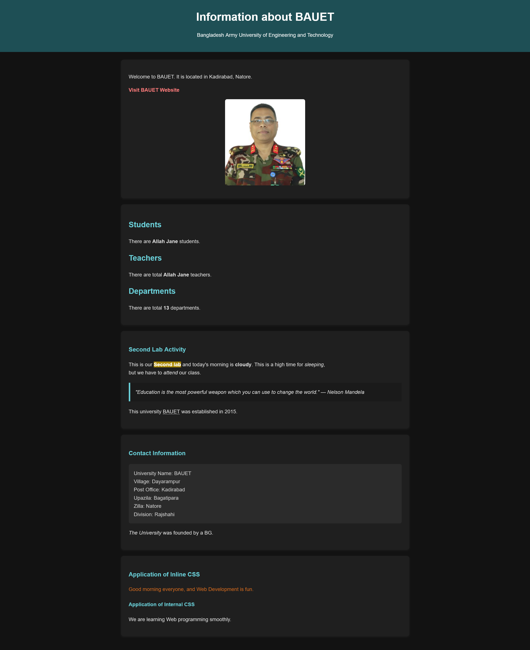
2.6 Output
Fig. 2.1: Dark mode of the Website

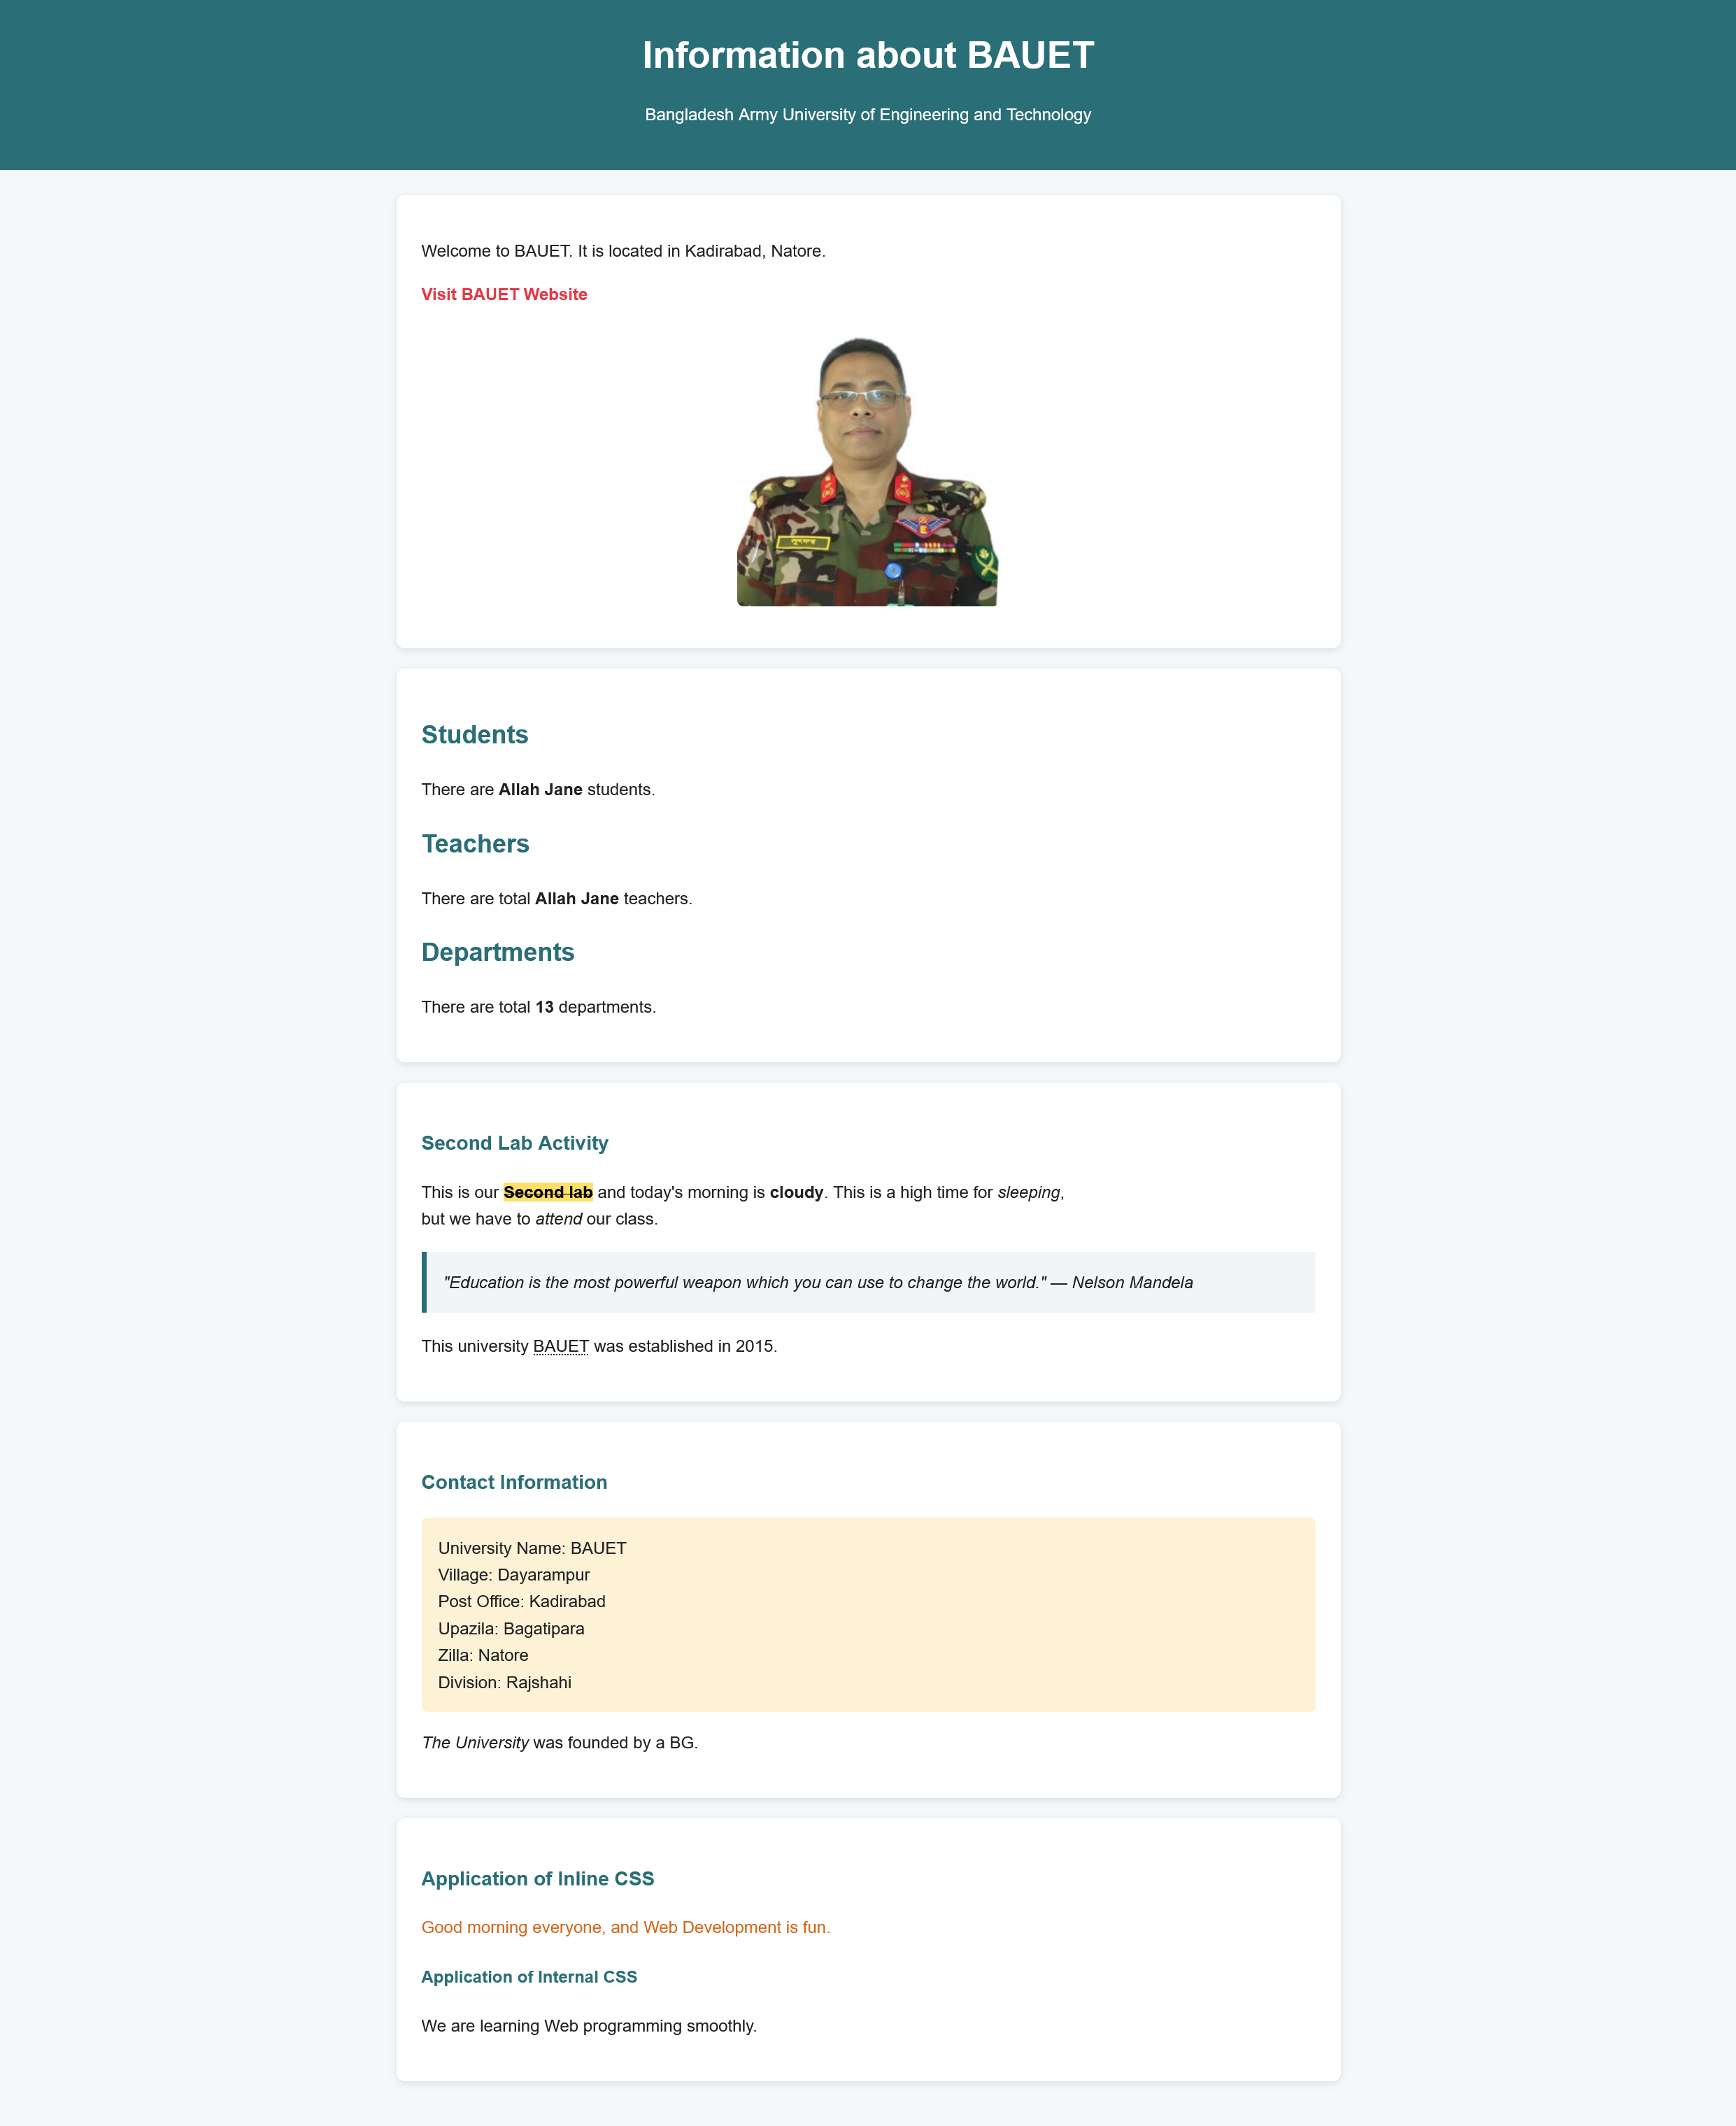
Fig. 2.2: Light mode of the Website

2.7 Discussion
In this experiment, various HTML attributes were applied to create a structured and semantically meaningful webpage. Text emphasis and readability were enhanced through the use of formatting tags such as <b>, <strong>, <em>, and <mark>. Navigation and SEO control were improved by applying hyperlink attributes like href, rel, and target. Meaningful context was added using semantic tags including <blockquote>, <abbr>, <cite>, and <address>, which also aided accessibility and search engines. Different methods of CSS styling—inline, internal, and external—were demonstrated to provide flexible presentation options. Overall, it was shown how HTML attributes contribute to the development of accessible, well-styled, and user-friendly webpages.

